
NSS UNIT VIT BHOPAL UNIVERSITY
Kotri Kalan, Astha, Indore – Bhopal Highway
Bhopal Madhya Pradesh -466114

EVENT REPORT
Date | 13th May, 2024
Event Name | Water and Food for Birds
Event Date | 8th May, 2024
Venue/Mode | Campus Premises, Physical Mode
No of Students Registered | 44
No of participants | 15
Faculty coordinator(s) | Dr. Vinod Bhatt, Dr. Abha Gupta
Brief about the event (context and Learning outcomes)
On May 8, 2024, the NSS unit of Vit Bhopal placed 15 bird feeders and water pots on campus premises in front of the Academic Block to MPH.
The project aims to offer the birds living in the campus ecosystem, or those that visit, a way to eat and drink, especially during times of scarcity. This creates a welcoming environment for avian species and promotes biodiversity within the campus ecosystem. By installing feeders and water pots, we strive to support bird populations. This also enhances the campus environment and promotes environmental awareness.
This program offered several valuable learning outcomes like the act of placing and maintaining feeders fostering a sense of community and responsibility for the campus environment. Providing for the birds' needs shows our commitment to environmental stewardship and sustainability practices. Understanding the challenges birds face in urban environments fosters a sense of responsibility toward their well-being.
We planned to refill feeders regularly with appropriate birdseed (Bajra) and maintain the cleanliness of the feeders and water pots. Furthermore, we aim to place more than 50 feeders and water pots across the campus premises to ensure a consistent source of sustenance for the birds. This proved to be a successful initiative. It not only benefits the birds but also enhances the overall campus environment.

Photos (5-7 Best event pictures)
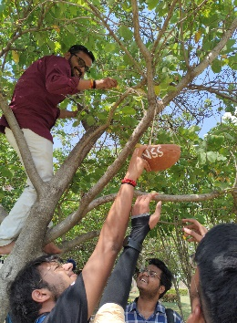
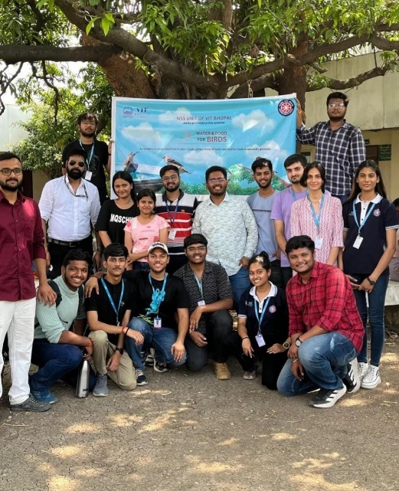
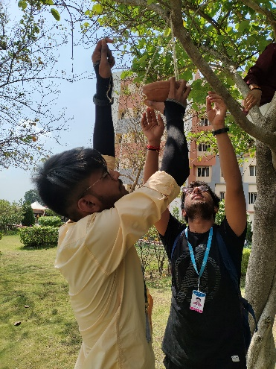
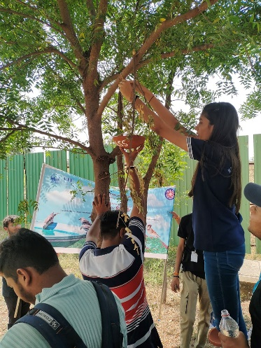
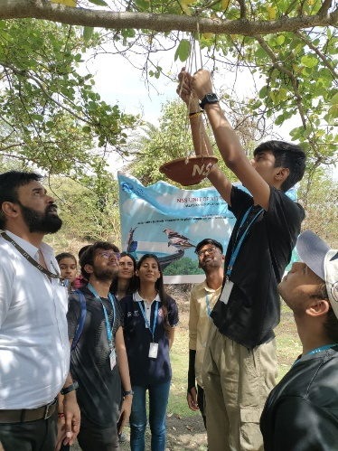
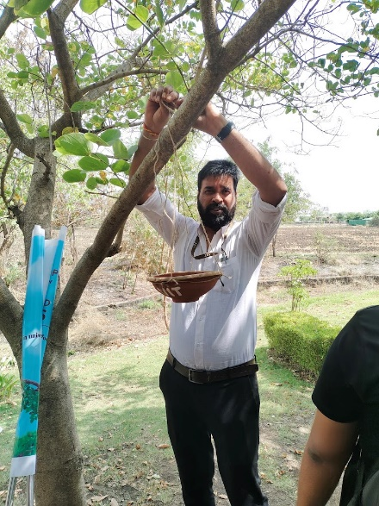
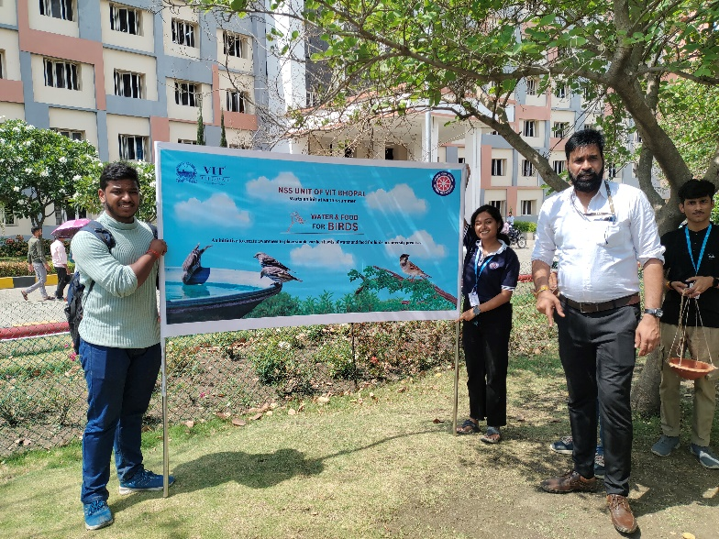

Student Coordinator(s) (mention only 2) | Riya Gehlot, Nitank Dasondi
List of Participants
- Anushka Jena
- Anmol mehta
- Omanshi Kaushal
- Ayush Saxena
- Riya Gehlot
- Taruna Gupta
- Shivang Gaur
- Ayush Raj Pandey
- Rishabh Kabra
- Nitank Dasondi
- Khushi Desai
- Ishita
- Jai Palan
- Eashan Batra
- Ambika Sharma
- Jayesh Jaiswsal
- Pranjal Bhargava
- Anushka Soni
- Sanika Awal
- Ayush Karkare
- Harshit
- Aranya Bhauguna
- Prashant Kumar
- Tanishika Shnadilya
- Kripa Kalal
- Mukesh Ghosh
- Shreya Gupta
- Prabhat Tiwari
- Aditya Kumar Lala
- Samiksha Panwar
- Ayush Pandey
- Pracheer
- Diksha
- Pratap Choudhary
- Ayush
- Divya Mathur
- Akshat Bansal
- Rajat Shrama
- Shambhavi Patil
- Yatharth Nagpal
- Aishwarya Tripathi
- Archana
- Pranshii

Budget and expenditure (enclosed by program officer with signature)

